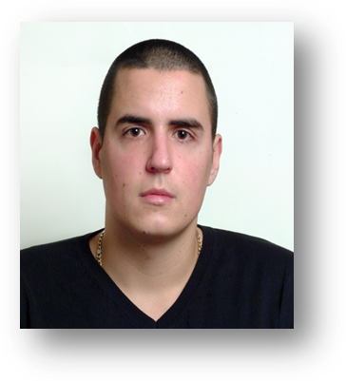
Nikola Blagojevic
Cerska 21,34300 Arandjelovac, Serbia
Email: nikolablagojevic1@gmail.com Phone: 38169620555

EDUCATION

High school:Technical school, Arandjelovac, Serbia 2008-2011
Degree awarded: Electrical technician computer

Faculty of Technical Sciences, Cacak, Serbia 2011-
Department: Technics and Informatics

WORK EXPERIENCE

Karoserija Servis, Lazarevac, Serbia 2008-2010
Network manager
Provide technical support
Support staff queries
Monitor system use

Alfa Team, Arandjelovac, Serbia 2012-2014
Programmer, technical support
basic work in C++
Office package(word, excel)

Knjaz Milos, Arandjelovac, Serbia 2013-2013
Technical support

SKILLS
Computer/technical skills: Microsoft Windows (Advanced knowledge of Microsoft ® Windows environments (xp, vista, 7, 8), Microsoft Office (Office package), C++, Pascal and AutoCad(intermediate level)
Language ability: Serbian - Native speaker
Croatian - C2
English - C1

INTERESTS

Current hobbies and interests: Traveling and learning about other countries and their cultures, Clubbing, Reading books, Sports – (basketball, football)

OTHER

Driving license

